CR Flex
Corey Scholes
2026-03-10
Table of contents
1. Preamble 1
1.1 Retrieve MMM 1
2. Context 2
3. Recruitment Flow 2
4. Baseline and Demographics 4
5. Complications 9
6. Patient reported outcomes 11

1. Preamble
The following analysis is a report on the activity, quality and data contained in the AORA registry.
Access to the AORA datasets was pre-authorised.
A function was generated to retrieve files to call on later in the analysis for processing data imports.
Data was retrieved from live database tables. Source files were specified and stored as global variables to call on in further functions.

1.1 Retrieve MMM
Rows: 3,420
Columns: 4
$ `POA 2021 Code` <dbl> 800, 810, 812, 820, 822, 822, 822, 8…
$ `POA 2021 Area (km2)` <dbl> 3.1731, 24.4283, 35.8899, 39.0642, 1…
$ `MMM 2023` <dbl> 2, 2, 2, 2, 2, 5, 6, 7, 2, 2, 2, 5, …
$ `MMM 2023 Area in POA 2021 (km2)` <dbl> 3.173800e+00, 2.442859e+01, 3.588975…
A static registry snapshot was retrieved and formatted based on the fixed date of preparation of the snapshot (01-Dec-2025).

2. Context
The Arthroplasty Outcomes in Regional Australia (AORA) registry has been in operation since June 2020, collecting KneeArthritis and HipArthritis presentations to a private clinic in Grafton, NSW. The setup of the registry is detailed on the registry wiki. The registry started with two surgeons contributing with one surgeon stopping participation in December 2022.

3. Recruitment Flow
Flowcharts as per STROBE (Vandenbroucke et al. 2007) and RECORD (Benchimol et al. 2015) guidelines were generated for treatments enrolled into the Registry. Followup was set to eligibility at 3months followup.
Need to identify GMKSubset to flag in STROBEInput for flowchart
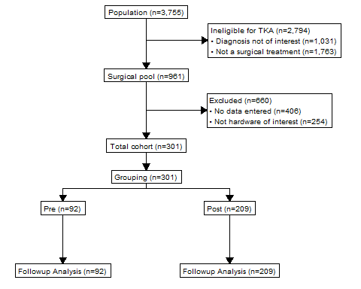
Figure 1: Flowchart of extraction and followup of surgical sample from the Registry
Cumulative recruitment over time was plotted from Registry inception to the present.
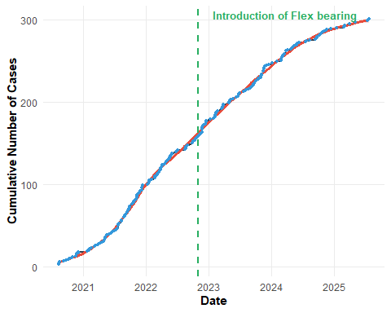
Figure 2: Cumulative cohort recruitment within the registry from inception to present

4. Baseline and Demographics
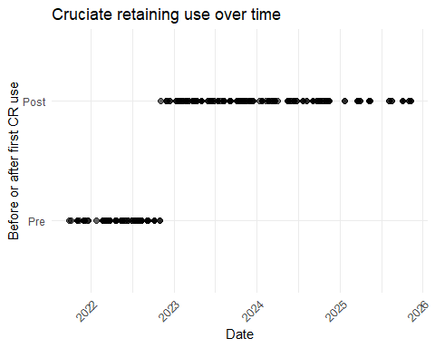
Table 1: Summary of demographics comparing pre vs post flex introduction
Characteristic | Overall N = 300¹ | Pre N = 92¹ | Post N = 208¹
AgeAtTreatment | 69 (63, 75) | 67 (61, 73) | 70 (63, 76)
Sex
Female | 150 (50%) | 44 (48%) | 106 (51%)
Male | 150 (50%) | 48 (52%) | 102 (49%)
EducationLevel
Post-secondary trade certificate or diploma | 53 (27%) | 18 (27%) | 35 (27%)
Postgraduate degree | 24 (12%) | 6 (9.1%) | 18 (14%)
Secondary - Year 12 | 21 (11%) | 8 (12%) | 13 (10%)
Undergraduate degree | 22 (11%) | 6 (9.1%) | 16 (12%)
Up to Secondary Year 10 | 75 (38%) | 28 (42%) | 47 (36%)
mmm_label
Large rural town | 19 (6.7%) | 2 (2.2%) | 17 (8.8%)
Metropolitan | 1 (0.4%) | 1 (1.1%) | 0 (0%)
Regional centre | 2 (0.7%) | 1 (1.1%) | 1 (0.5%)
Remote community | 83 (29%) | 20 (22%) | 63 (33%)
Small rural town | 91 (32%) | 30 (33%) | 61 (32%)
Very remote community | 89 (31%) | 38 (41%) | 51 (26%)
SACQ_score | 5.0 (3.0, 7.0) | 5.0 (3.0, 7.0) | 5.0 (3.0, 7.0)
MODEMExp | 18.0 (15.0, 21.0) | 18.0 (15.0, 21.0) | 18.0 (16.0, 20.0)
KOOS12_Pain_TotalScore_Preop | 38 (31, 50) | 38 (25, 47) | 38 (31, 50)
VR12_Physical_TotalScore_Preop | 30 (23, 35) | 29 (23, 34) | 30 (24, 35)
VR12_Mental_TotalScore_Preop | 58 (50, 62) | 59 (50, 63) | 57 (50, 62)
TreatmentStatus
Failed | 3 (1.0%) | 3 (3.3%) | 0 (0%)
No further followup | 1 (0.3%) | 1 (1.1%) | 0 (0%)
Ongoing | 296 (99%) | 88 (96%) | 208 (100%)
DateTreatment | 2021-09-27 - 2025-11-10 | 2021-09-27 - 2022-11-02 | 2022-11-04 - 2025-11-10
¹Median (Q1, Q3); n (%); Min - Max

5. Complications
Table 2: Summary of complications incidence after surgery separated by group
Characteristic | Overall N = 300¹ | Pre N = 92¹ | Post N = 208¹
ComplicationOccur2
No | 250 (83%) | 65 (71%) | 185 (89%)
Possible | 30 (10%) | 21 (23%) | 9 (4.3%)
Yes - Surgeon Confirmed | 20 (6.7%) | 6 (6.5%) | 14 (6.7%)
OccurDelay² | 12 (5, 117) | 9 (5, 16) | 26 (6, 286)
Followup² | 845 (558, 1,194) | 1,318 (1,209, 1,375) | 677 (451, 899)
¹n (%); Median (Q1, Q3)
²Days

Adverse events were detected in 16% of surgical cases performed by SM over the life of the registry as shown in Table 2, with an average detection with 30 days of surgery.
Write complications table for SM review

6. Patient reported outcomes
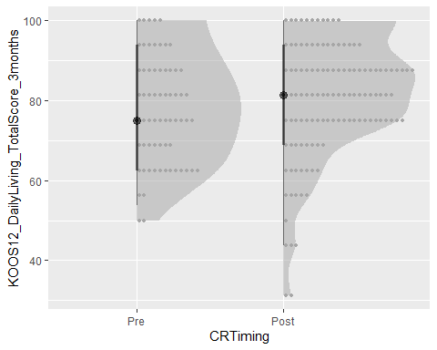
Table 3: ANCOVA: 3month KOOS scores adjusted for baseline
Characteristic¹ | Beta¹ | 95% CI¹ | p-value¹
Daily Living | 1.3 | -3.4, 5.9 | 0.6
Pain | 1.5 | -4.4, 7.4 | 0.6
Total | 1.2 | -3.7, 6.2 | 0.6
¹β = adjusted mean difference (Treatment vs Control); adjusted for baseline subscale score.
Abbreviation: CI = Confidence Interval

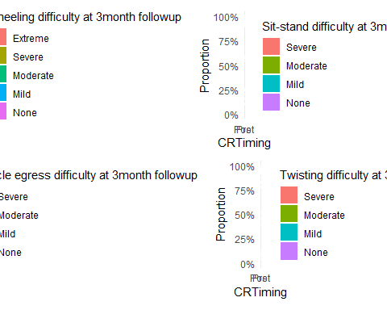
Figure 3: Response patterns of kneeling and daily living difficulty at 3months before vs after introduction of flex bearing

# weights: 25 (16 variable)
initial value 299.355452
iter 10 value 243.673002
iter 20 value 238.986941
iter 30 value 238.884814
iter 30 value 238.884814
iter 30 value 238.884814
final value 238.884814
converged
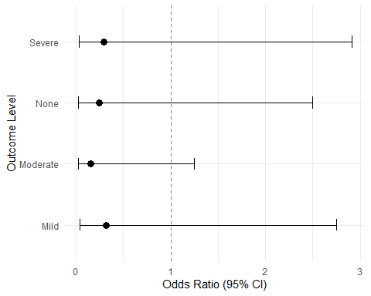
Figure 4: Adjusted odds ratios before vs after introduction of flex bearing

Benchimol, Eric I., Liam Smeeth, Astrid Guttmann, Katie Harron, David Moher, Irene Petersen, Henrik T. Sørensen, Erik von Elm, and Sinéad M. Langan. 2015. “The REporting of Studies Conducted Using Observational Routinely-Collected Health Data (RECORD) Statement.” PLOS Medicine 12 (10): e1001885. https://doi.org/10.1371/journal.pmed.1001885.
Vandenbroucke, Jan P, Erik von Elm, Douglas G Altman, Peter C Gøtzsche, Cynthia D Mulrow, Stuart J Pocock, Charles Poole, James J Schlesselman, and Matthias Egger. 2007. “Strengthening the Reporting of Observational Studies in Epidemiology (STROBE): Explanation and Elaboration.” PLoS Medicine 4 (10): e297. https://doi.org/10.1371/journal.pmed.0040297.

